Information Literacy – Summer 2021 Results

Report prepared by Kendall McGoey (Graduate Assistant for Data Analytics; Office of Academic Insight) and Katie Boyd (Director of Academic Insight).

Executive Summary

Sample
In total, 5,347 students were eligible for and enrolled in this course. Each student took the Evaluating Process & Authority module from the Information Literacy “Threshold Achievement” test as part of Connecting the Creed in Summer 2021. While 5,347 students were assigned the module, not all students successfully completed it. Of note, 4,985 students completed the Evaluating Process & Authority portion. In terms of motivation data, only 4,490 of the 4,985 students had completed Student Opinion Survey (SOS) responses. Students with duplicate or missing data were excluded from analyses beyond the exploration of motivated cases. Generally, students were moderately motivated to take the assessment and were neutral about the test’s importance. In total, 558 students were identified as ‘unmotivated’ and removed from the sample. One additional student was removed as he was enrolled in the Path to the Plains, Provost program and did not fit the category of non-transfer freshmen students that we analyzed. The remainder of this report shows analyses of the module with motivated cases (N = 4,426).
Overall Performance
Figure 1 displays the overall average score and sub-scores for motivated students within Module 1. As shown below, the highest average overall score for Evaluating Process & Authority was M = 502.31. Subsequent exploratory analyses revealed statistically significant gaps in knowledge, which are further explored throughout the report and mentioned in the ‘Main Takeaways’ section at the end of this report.

Figure 1 – Evaluating Process & Authority Scores

Note. N = 4,426; “Evaluating Process and Authority” references the Overall average.

The Test
The Threshold Achievement Test for Information Literacy (TATIL) was a test inspired by the ACRL Framework for Information Literacy for Higher Education and helps educators determine the capabilities of their students within four areas: Module 1 – Evaluating Process & Authority, Module 2 – Strategic Searching, Module 3 – Research & Scholarship, and Module 4 – The Value of Information. Auburn University implemented Module 1 during the Summer 2021 semester.
More specifically, Module 1: Evaluating Process & Authority focuses on a student’s ability to judge source authority, analyze claims, and support their individual claims. There are two knowledge outcomes (Apply knowledge of source creation processes and context to evaluate the authority of a source; Apply knowledge of authority to analyze others’ claims and to support one’s own claims) and three disposition outcomes (Mindful self-reflection; Toleration of ambiguity; Responsibility to community) that make up this module.

Background

Changes to General Education Assessment
From 2011 until 2015, general education was assessed through a “course-embedded” assessment approach. That is, faculty teaching core courses were asked to evaluate student work in their courses using a rubric developed by the Core Curriculum General Education Committee (CCGEC). There were eleven student learning outcomes and associated rubrics. In Fall 2015, the CCGEC began a year of reflection in which they met with faculty across campus to explore the effectiveness of the course-embedded assessment approach. Generally, the committee found that this approach was not working well for formative or summative assessment purposes. In 2016, the CCGEC began exploring other assessment options in an effort to centralize assessment and focus on graduating seniors. With this new focus, faculty working groups around each student learning outcome were tasked with (1) re-stating the student learning outcome with graduating seniors in mind, and (2) identifying, developing, or refining a measure aligned with the student learning outcome. All student learning outcomes were finalized by the CCGEC and approved by the University Senate in October 2017.

Outcome, Assessment, and Alignment
Formerly labeled “SLO 1” the original information literacy outcome statement reads (2011): Students will be information literate. The working group for this outcome was composed of a faculty member from the English department and three faculty members from the library. To meet their charge, the working group met bi-weekly during the 2016-2017 academic year to create a new outcome statement. Specifically, outcome 1 was refined to: “Students will be able to locate, evaluate, and use information.” The CCGEC, to create consistency, developed a preface statement for the set of outcomes; thus, the new outcome reads in totality:
“In order to become lifelong learners and use their education to solve practical problems, by the time of graduation, students will be able to effectively… locate, evaluate, and use information.”
The working group also determined 4 sub-outcomes:
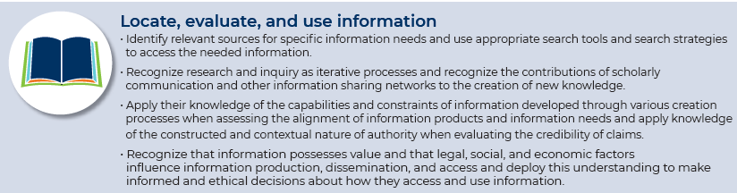
To evaluate this outcome and the sub-outcomes the working group decided to purchase the TATIL test. The TATIL has four modules, each aligned with one of the above sub-outcomes.

Information Literacy testing
Launched in 2020, Auburn’s Connecting the Creed program aims to enhance students’ personal qualities, experiences, and life skills across areas of financial wellness, mental health and physical well-being, civic literacy, and core competencies. By emphasizing the values personified by the Auburn Creed, this program highlights specific areas of personal development critical to inspiring and preparing our students for life and careers.
All incoming students are required to complete four assessments to gauge their understanding of (1) Financial concepts, (2) Mental Health and Physical Well-being concepts, (3) Civics concepts, and (4) Information Literacy concepts. As an incoming student, they must complete all four assessments. Participation status remains incomplete until all four assessments are finished. Students who have an incomplete participation status will receive reminders to complete expectations of the Connecting the Creed course. Students are told that an incomplete status may impact their registration for academic courses later in the summer.

